|  |
| --- |
|  |
| Screen Specification |
| Add New Copy Use Case |
|  |
| **Chu Quoc Hung** |
| **10-Mar-17** |

Screen Specification for Add New Copy Use Case.

Table of Contents

1. Pages 3

1.1. Page Tree 3

1.2. Home 4

1.2.1. User Interface 4

1.2.2. Widget Table 4

1.3. Add New Copy Popup 7

1.3.1. User Interface 7

1.3.2. Widget Table 7

1.4. Manage Book 9

1.4.1. User Interface 9

1.5. Manage Borrower Card 10

1.5.1. User Interface 10

1. Pages
   1. Page Tree

Home  
 Add New Copy Popup  
Manage Book  
Manage Borrower Card

* 1. Home
     1. User Interface

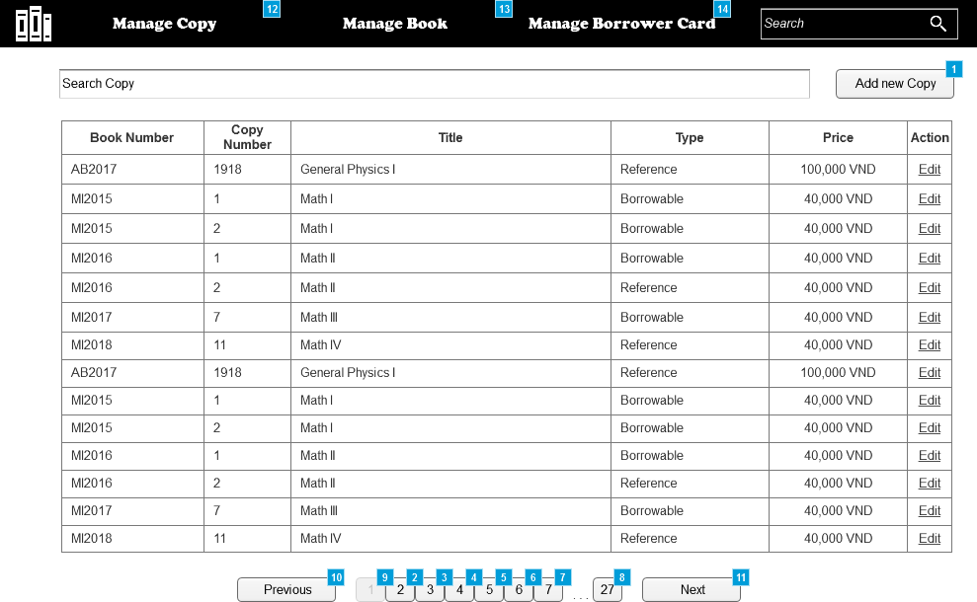

* + 1. Widget Table

|  |  |  |
| --- | --- | --- |
| Footnote | Name | Interactions |
| 1 |  | OnClick:  Case 1:  Show/Hide Widget  Open Add New Copy Popup in Popup Window |
| 2 | 2 | OnClick:  Case 1:  Hide (Table)  Show (Table) fade 500 ms  Enable 1, 3, 4, 6, 5, 7, 27  Disable 2 |
| 3 | 3 | OnClick:  Case 1:  Hide (Table)  Show (Table) fade 500 ms  Enable 1, 2, 4, 5, 6, 27, 7  Disable 3 |
| 4 | 4 | OnClick:  Case 1:  Hide (Table)  Show (Table) fade 500 ms  Enable 1, 2, 5, 6, 27, 7, 3  Disable 4 |
| 5 | 5 | OnClick:  Case 1:  Hide (Table)  Show (Table) fade 500 ms  Enable 1, 2, 4, 6, 27, 7, 3  Disable 5 |
| 6 | 6 | OnClick:  Case 1:  Hide (Table)  Show (Table) fade 500 ms  Enable 1, 2, 4, 5, 27, 7, 3  Disable 6 |
| 7 | 7 | OnClick:  Case 1:  Hide (Table)  Show (Table) fade 500 ms  Enable 1, 2, 4, 5, 6, 27, 3  Disable 7 |
| 8 | 27 | OnClick:  Case 1:  Hide (Table)  Show (Table) fade 500 ms  Enable 1, 2, 4, 5, 6, 3, 7  Disable 27 |
| 9 | 1 | OnClick:  Case 1:  Hide (Table)  Show (Table) fade 500 ms  Enable 3, 2, 4, 5, 6, 27, 7  Disable 1 |
| 10 |  | OnClick:  Case 1:  Hide (Table)  Show (Table) fade 500 ms |
| 11 |  | OnClick:  Case 1:  Hide (Table)  Show (Table) fade 500 ms |
| 12 |  | OnClick:  Case 1:  Open Link in Current Window |
| 13 |  | OnClick:  Case 1:  Open Manage Book in Current Window |
| 14 |  | OnClick:  Case 1:  Open Manage Borrower Card in Current Window |

* 1. Add New Copy Popup
     1. User Interface

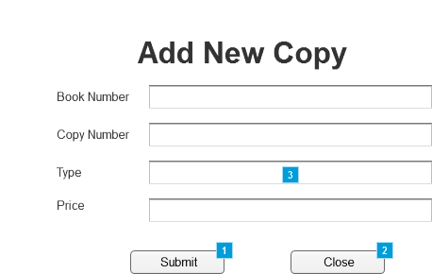

* + 1. Widget Table

|  |  |  |
| --- | --- | --- |
| Footnote | Name | Interactions |
| 1 | button submit | OnClick:  Case 1  (If text on text field book number does not equal "" and text on text field copy number does not equal "" and text on text field price does not equal "" and text on text field copy number does not equal "" and text on text field price is numeric and text on text field copy number is numeric ):  Close Current Window  Case 2  (Else If True):  Show error text, back button, image error  Hide (Shape), (Shape), text field copy number, text field type, (Shape), (Shape), (Shape), text field price, text field book number, button close, button submit, This |
| 2 | button close | OnClick:  Case 1:  Close Current Window |
| 3 | back button | OnClick:  Case 1:  Show (Shape), (Shape), text field copy number, (Shape), text field type, (Shape), (Shape), text field price, text field book number, button close, button submit  Hide image error, back button, error text |

* 1. Manage Book
     1. User Interface



* 1. Manage Borrower Card
     1. User Interface

